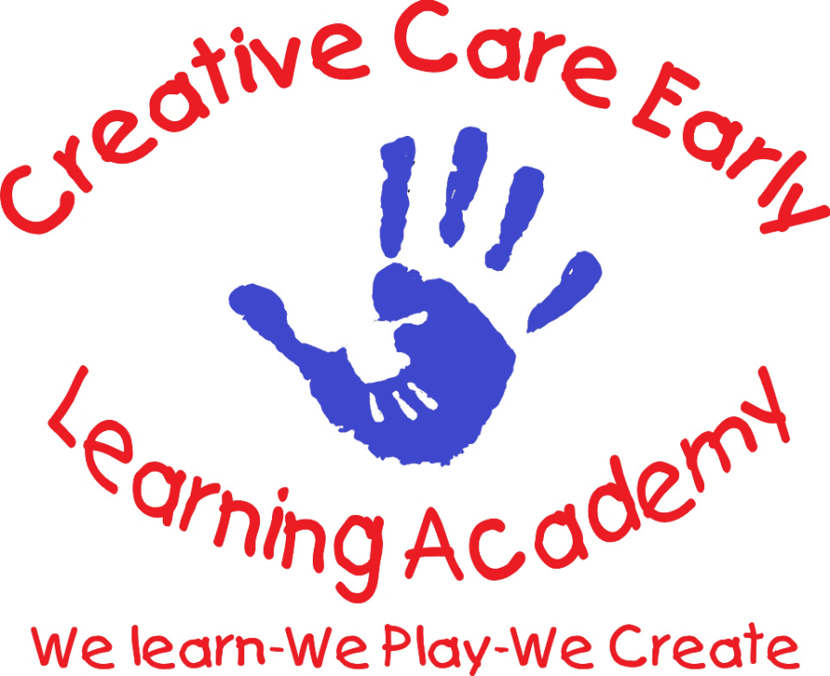
EARLY LEARNING

“WE LEARN–WE PLAY-WE CREATE”

PARENT HANDBOOK

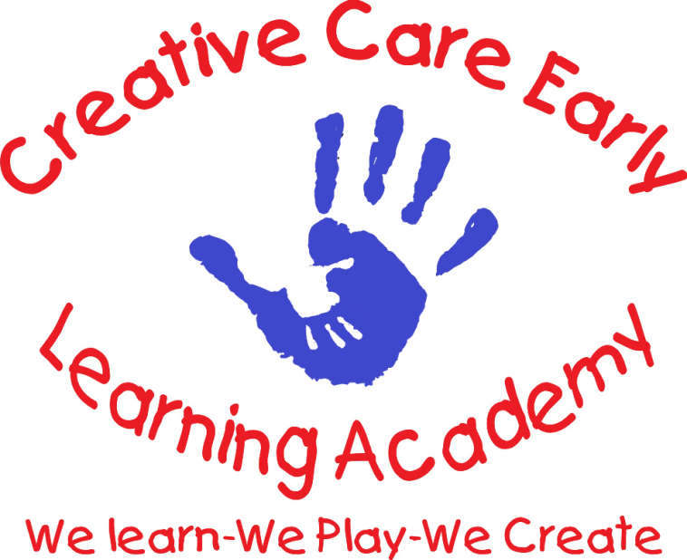
WORKING PARENTS WITH NO WORRIES

PARENTS:
As owner of Creative Care Early Learning Academy. I, along with the Creative Care, ELA family would like to welcome you to our childcare facility. We are happy that you have decided to become a part of our wonderful childcare family. As a new or returning family, or if you have been with us for some time, you are a valuable asset to our childcare center. We will strive daily to provide you and your family with an invaluable quality of childcare through our service, expertise and resources.
We are your Childcare Specialists we pride ourselves in offering Early Learning Education and Resources. We hope that you feel the warmth and security of our family environment as we put forth our best efforts each day to service your childcare needs.
It has continued to be one of our many goals as we build relationships with all of our new or returning families- we strive daily to make your children and your family our top priority.
We want to ensure that our parents are comfortable to “Work with no worries”- after leaving your precious children in our care each day.”
Sincerely
Carolyn C. McNair-Owner
Creative Care Early Learning & Prestige Academy

OUR PHILOSOPHY
At Creative Care Early Learning Academy, our goal is to foster the developmental growth, creativity and passion that young children are born with.
We value the importance of learning through play, we strive to provide the tools that promote creativity, respect, nurturing, care and learning in a loving play based environment.
Covered with God’s love, prayer and gentle guidance, it is our belief that children will expericene a blossoming of success, grow strong creative minds and characters that are overflowing with success and knowledge.
Developing from the small wondering caterpillar into a beautiful soaring butterfly!
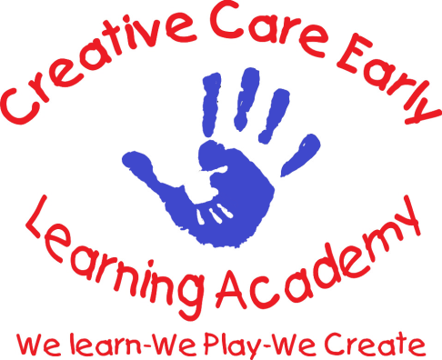

OUR MISSION: We will strive to build and maintain strong, lasting and professional partnerships with our childcare families, the community that we serve. We purpose to continue to grow in knowledge, wisdom and success.
Our ultimate goal is to motivate and inspire young children to become great creative leaders of tomorrow through the empowering love of Jesus Christ daily.

TRANSITIONS

Transitions are often times very scary for children enterings into a new environment. One of the key factors in making transitons easier is communication and time. Clear communication should start from the beginning of the new relationship. Transitions will be carefully monitored, communicated and documented.
This process usually takes about two to three weeks of gentle separation and guidance for the child to become secure in their new play space environment. Again, transitions are seldom easy and take time.
Here at Creative Care ELPA we offer patience, love and compassion and respect as we build new relationships with children and families. It is our expereince, that these tools are also necessary for building and promoting strong, trusting and lasting relationships between the daily provider, child and family.
We are aware that our parents also transition as well as the children, please be assured that your child will be in the best of care here at Creative Care ELPA. We will care for your child in a careful, watchful and professional manner at all times.

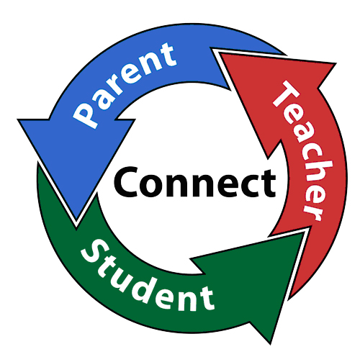

CONTRACT

Our Agreement Summary and Contract is located at the end of the Creative Care Handbooks for Families and Staff. It is a contract by signature acknowledging the completion of the enrollment process and is binding agreement to ALL policies and procedures of Creative Care Programs.
We offer a two week transition period (trial period). Which is monitored by the parents and childcare facility, either party can withdraw from the childcare arrangement if they are unsatified with the relationship or services. No deposits or childcare payments will be refunded.
During this time, the provider and family will conference to evaluate retification or if Creative Care ELPA is the best fit for the child or families childcare needs. After the trial period (2 weeks), the Contract will be signed and become effective immediately.
Child withdrawals are bound to a 3 week written notice along with payment. It is also expected that Creative Care ELA will also submit a 3 week notice if childcare should cease on our end. In the case of an emergency child behavoiral situation or parent conduct or confrontation where harm could result, childcare will cease immediately.
The form is binding between facility and family, to be renewed annually.

THIS IS A CHRISTIAN FACILITY, PLEASE TAKE THIS INTO CONSIDERATION IN YOUR SELECTION OF YOUR CHILDCARE NEEDS!

HOURS OF OPERATION
OPERATING HOURS:
Creative Care, ELPA hours of operation are as follows:
Monday – Friday 6:30am until 6:00pm.
Our ages of the children we serve range from birth to 10 years of age.
Care can not be provided before or after the stated hours. Exceptions extend to emergency situations and /or when prior arrangements have been made. There will be a 10 hour contracted arrival to pickup time for each individual family.

HOLIDAY AND VACATIONS:
Holidays, sick days or vacations do not effect the weekly rates of care. Creative Care Early Learning Programs follow a designated closure schedule each year. These dates may be subject to change throughout the year. Please note that there are also teacher work days and\or training days alloted for staff during the year which is posted with at least a two week notice.
Please follow the posted Creative Care Early Learning Academy yearly Holiday Schedule for the breakdown of scheduled paid holidays and/or other work days as most of these are Federal Holidays.
VACATION SCHEDULE:
Creative Care ELA will close for vacation during Christmas/New Years- (please see Holiday Schedule for dates.) A 3-week notice will be given and posted for any vacation times or Daycare closings. We allot each family a FREE WEEK of childcare each year –with a 30 day notice to schedule your vacation time. Please fill out the free vacation week form to schedule your yearly vacation time.

TUITION & FEES
Enrollment Fee and registration packets are needed to secure your child’s spot for childcare service. There is a Non-Refundable deposit due before any enrollment paperwork will be completed.
The Non-Refundable Deposit for your family is:__$150.00________.This Non-refundable deposit will be used as payment toward last week of care.
Weekly tuition fees are due by Tuesday of each week. All daycare tuition payments are expected as care is provided. Payment negligence will result in termination of care immediately.
Creative Care Early Learning Programs-childcare services are served by the week. We are not a monthly service facilty. You can certainly pay your fee by the month- by adding the weeks within the month…some months have 4 weeks of care and some months have 5 weeks of care. Please be careful to add the weeks of care correctly before sending in your monthly payments.
Monthly tuition payments are due on the 1st day of each month, if the 1st falls on a weekend date-Saturday or Sunday, then payment is due on Friday.
For All scheduled Creative Care ELA individual family vacations and all Holiday Closings and sick days(including Covid-19 Closures- payments are still expected and may be submitted through PayPal or CashApp on your scheduled payment date.

TUITION INCREASE:
A two week notice or longer will be given for any daycare rate increase.
LATE FEES:
PLEASE call if you plan to be late dropping off or picking up your child. Your phone call IS expected! Current late fees are: ______$2_____ per minute, exceeding the daycare closing time. NO EXCEPTIONS.
Please have correct late fee in hand when picking up .

MATERIALS/ENRICHMENT FEES: FISCAL MANAGEMENT
A materials or enrichment fee may be required for certain extra-curricular activities, fieldtrips or other projects hosted by the facility. Ample notice will be given for all extra activites.
PARENT PICK-UP
Children should arrive to daycare on time each morning. Your phone call or prior arrangments is expected if you plan to be late or not attend care for that day.
Care WILL NOT be provided after: __9:30am, if our staff is not notified in advance. Meals and actitivy supplies will need to be adjusted for childen not in care therefore advance notice is required. After 3 warnings -services will be considered for termination.
Each child should arrive and be picked up by his or her parent or gaurdian. If your child is picked up by someone other than the parents, that pickup individual name MUST appear on the completed information form in your child’s file, otherwise pickup will not be permited and DSS will be notified.
Advance notice will help elevate problems regarding daily drop off and pick up assignments. Child drop off or pickup is not allowed by any sibling under 16 years of age without advance notice to director or Admin team.
Regarding custody matters, all notarized documents must be signed by the courts to confirm all issues regarding custody of the child and place in your childs daycare file. Court document as must clearly state who is responsible for drop off and pickup. Creative Care ELA will not deny parental rights without documented information of release.
PLEASE DO NOT USE THIS DAYCARE FACILITY AS A GO BETWEEN FOR PERSONAL FAMILY SITUATIONS AND CURCUMSTANCES!

IMMUNIZATION, ILLNESS & MEDICATION
Please be sure that your child is up-to-date with any and all required immunizations. The NC state policy requires that each child be immunizied within 30 days of beginning childcare. A copy of your child’s shot record will be added to the complete enrollment packet forms that make up your child’s daycare file for review by the NC State Consultant.
This information will remain CONFIDENTIAL at the childcare facility. Please be advised that every immunization period an up-to-date shot record is due for filing and consultant annual visit review.
PLEASE see center director for family/religious non-immunization policies.
ILLNESS
If your child is sick, they should be monitored at home. Attendance is not allowed for that day or days of illness… if children do not feel like being active or playful during childcare they will not be successful and would be better cared for at home. If sickness occurs while in care, parents will be notified to pick up the child as soon as possible. Please provide an active phone or cell number that you can be reached without delay if the need arises.
Certain illnesses warrant a 24 hour (or more) absence from group care. This allows the spread of illnesses to other children or staff to remain under control within the childcare facility. Any child with a fever, vomiting, diarrhea, rashes, conjunctivitis, persistant/uncontrolable cough or runny nose, along with any other type of contagious desease must be kept at home. The child will be checked for tempurtures if administration or staff warrant the need or notices child behaving sickly or feels warm when held or touched. If fever registers more that 101’ the child must be picked up as soon as possible.

MEDICATION
Creative Care, ELA medication policy requires- If possible, all medicines should be administered at home with the exception of asmatic or life threating illnesses that require daytime dosage. All medications must arrive in the original container.
Medicine forms are required to be completed before any medications are given. No medication can be administered without written permission from the child’s parent.
If your child suffers from food allergies, please have an extra allergy pin or allergy medication available with parental written consent for emergency use at the daycare facility. Individual forms will be posted for allergic purposes.
The parent must indicate in writing the name of medication, exact dosage, child’s name & days to be administered. Designated Creative Care staff will sign off on forms as the medicine is adminsitered.

NUTRITION
Creative Care ELA is a participant in the NC Adult & Child Food Program. Each child will be enrolled as a participant in the food program that moniters daily meals during childcare hours.
Infants under 12 months of age, the family will be responsible for the supply of all formula or breast milk. As the child grows and requires food items to be added to their meals, the daycare facility will provide all cereals, snacks and baby food items.
For all infants, parents are required to complete an Infant Feeding Schedule form until 15 months of age.
Children who are 12 months or older, ALL food and snack items will be provided through the childcare facility. Selected food items are nutritious, well balanced, fresh or fresh/frozen and monitored by the NC Food Program 3-4 times per year by unannounced visits to ensure compliance of proper nutrition and the high standands of the Food Program.
Weekly menus are posted to inform parents of daily snacks and meals. Menus are revised and rotated seasonally or as needed. Please notify the facility of any and all food allergies your child may have developed. Parent are free to send prepared nutritious balanced meals for their child to enjoy, please notitfy director if you plan to do so. If you would like to supply a special snack for your child or the children, all items must be purchased from a supermarket or bakery- because of any known or unknown allergies or reactions. No exceptions to this policy.
NAPTIME
After a busy day of play and learning activities, each child will need to rest after lunch. Naps are not enforced but offered to each child, the child can have their favorite blanket or lovey from home.
If the child does not feel sleepy, he/she may enjoy a quiet activity on their cot or mat. A puzzle, book or quiet manipulative toy or actitivy will be offered to them to settle down which will often lead to a wonderful naptime experience.
This quiet time is for all classroom participants, soft gentle lullaby songs, nature sounds and –or storybook cd’s are used as naptime tools for rest and settle children to nap.

PERSONAL ITEMS
All items brought to daycare should be labeled with your child’s name.
Key: LABEL EVERYTHING OR ITEM!
Each child will need extra items for daycare, clothing that can be kept neatly in their cubby bucket in case of accidents or emergencies. Each child will have a designated cubby space, this is not a space for powders, oils, sunscreens or diaper cream. No diaper bags are to be left at the facility at anytime for any reason. Please let the staff know if bringing in or taking out items, remember to change out clothing due to seasons and children growing out of clothing.
Bibs for feeding are not required for any age, the facility will supply all feeding support items to control mixing of home and daycare supply.
Extra items for daycare may include: clothing, shoes, under garmets, socks, jackets, rain boots, hats,pacifiers and gloves. Again, label your items.
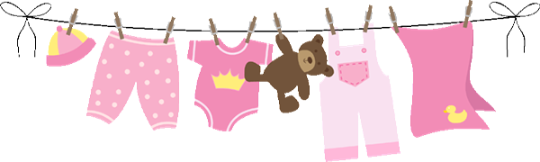
TOYS
It is the best practice NOT to bring your child’s personal toys to daycare. We do offer select Show & Share Days for that purpose. Typically, bringing in personal items from home to school leads to children being over protective of what belongs to them and other non-sharing emotions.
We provide structured and educational toys and learning equiptment for the children each day. These items are safe and of the best quality. The toys and equiptment is sanitized each day to control the spread of germs along with proper hand washing between staff and children.
Again, please keep personal toy items in the car for the ride to and from school.

FIELDTRIPS AND ENRICHMENTS
We offer occassional field trips and on-site, off-site enrichment actitivites to enhance the learning experiences. In order for your child to participate the appropriate forms must be signed and dated.
Field trips will be posted in a timely manner as extra fees may apply. Fees may include entrance fees or participation fees and lunches or snacks. Enrichments are planned as lessons evolved for learning experiences.

DISCIPLINE AND TERMINATION
Creative Care follows positive discipline proceedures for each child. We believe positive behavioral management will build and promote good values and self esteem in each child.
Please see the Discipline and Behavior Management Policy for more details.

The termination policy is as follows:
Continued disruptive and or abusive, harmful behavior to other children or staff.
Continued abuse to Creative Care, ELA policies and procedures.
Continued or the inability to follow policies of payments, tardiness, attendance to contracted time schedules, late pickup and payments. Children should be in care each day by 9:30am.
Conferences will be scheduled to discuss matters of incompliance to daycare rules and procedures by child or parent. There will be 2 warning letters- marked confidential , 1 conference and then TERMINATION.
Hitting, kicking, pinching, bitting, or spitting are all items that may warrant parent conferences to discuss behaviors. During this conference we will discuss goals for positive behavior changes. Action plans will be put in place to help the child in any way to become a successful member of our school.
The above stated reactions are not allowed or tolerated at anytime at Creaive Care, ELA to other children or staff. If these measures are ineffective, then a timely notices will be given to seek outside behavioral assistance, a two week notice will be given to seek out this assistance and set appointments. As this attempt is monitered by administration but seems to be non effective a timely notice will be given for termination.
The facility will work with the family to seek other childcare services if needed. Daycare facilities must have the appropriate guidelines and proceedures in place to run smoothly in order to operate successfully and safely for all.

STAFF DISCIPLINE AND INTERACTION GUIDELINES: Children will be adequately supervised at all times. Staff must be positioned in the clasroom to maximize their ability to see and hear the children at all times. Staff must know where children are at all times and be aware of their activities, as well as provide appropriate supervision according to ages and stages of development. Staff must be available to see children while they are napping and eating. For a copy of the Creative Care Staff Discipline Policy…please see administration.

PARENT COMMUNICATION
As a form of parent communication, parent meetings are held annually, semi- annually or as needed per year. Parent meetings are informal sessions to update forms, brainstorm ideas, parent workshops or trainings and different activities for the betterment of the facility and our families.
Fundraising actitivies or any other daycare projects are expected family participation roles- during your time at Creative Care, ELA. Working together as a team is key in reaching goals to grow our facility as well as the children enrolled.
Most activities are hosted by our Parent Advisory Committee, the chairperson of the PAC committee will contact each family by email, text or message in regards to the upcoming event/s to help with pulling together resources pertaining to the event. This committee is very important to Creative Care members and staff.
Parent communication boards are located throughout the facility. Please check the boards daily for important notes, closings, classroom wishlist and goals or other daycare announcements.
Parents are always welcome to Creative Care, ELA. Parent help is always welcomed as well, reading books or helping with special actitives. You can volunteer at anytime, please take into consideration the response of your child when you plan to visit. Some children may not be able to understand or cope with parent visits.
Creative Care, ELA provides monthly activity calendars and newsletters.

PROCEDURES FOR REPORTING ABUSE AND NEGLECT
While we want nothing but the best for our children, childcare abuse and neglect are too common.
All staff members of Creative Care ELA are mandated reporters and are required to report any suspected abuse, neglect or maltreatment on the part of an employee, parent or volunteer. Each staff member is trained in NC Child Neglect & Maltreatment and the NC Shaken Baby Syndrome Policies
each staff member has a Certificate of Completion placed in their files for State Consultant view.
Any abuse or maltreatment of a child, either as an incident of discipline or otherwise is prohibited. Any means of corporal punishment will not be tolerated.
Additionally, withholding or using food, rest, or sleep as a punishment is prohibited. If any thype of abuse or neglect is suspected it will be reported to the NC Department of Social Services, the mandated number is 919-560-0810.

The local address of our Health Department: 414 East Main Street or PO Box 810 Durham NC 27702-0810

DAILY – WEEKLY AND MONTHLY CLEANING PROCEDURES

Cleaning sanitizing and disinfecting are important steps to reducing the spread of germs and viruses in the childcare setting. Routine cleaning with liquid soap solution and water removes dirt and grim from surfaces. Sanitizing removes dirt and germs but some childcare areas need added disinfecting after cleaning and sanitizing to kill most surface germs, such as diapering surfaces, tabletops, handwashing sinks, and toys.
All containers of bleach and soap solutions are clearly labled and out of reach of children at all times. Fresh soap and bleach solutions are made daily for staff use, any unused solutions are poured out at the end of each day.
Daily:
Tables/highchairs- used for eating and food prep washed and sanitized daily after each use.
Floors- swept, vaccumed and sanitized daily as well as trash disposals
Bathrooms- daily or more as frequently as needed including toilet seats
WEEKLY:
Cloth toys, Cubbies, cribs, sheets and blankets, mats, cots, dressup clothes and stuffed aninmals.
MONTHLY:
Deep disinfectant cleaning on general surface areas, immersing each toy in disinfecting solution, clean windows and doors.

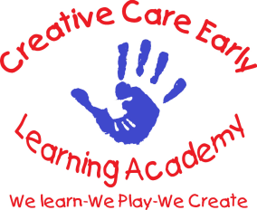
CREATIVE CARE EARLY LEARNING ACADEMY COVID-19 POLICY
The health and saftey of our children and staff is our highest priority here at Creative Care Early Learning Academy. We have implemented policies and procedures to minimize the risk of the spread of the virus known as COVID-19 in our facility. Because of the ever changing nature of this pandemic and the updated guidance that we receive from the NC DHHS Childcare Toolkit, our procedures are subject to change as we respond to new recommendations from health officials.
To keep Creative Care open, we need to work together as we follow the guidelines handed down to us.

WHEN TO KEEP YOUR CHILD AT HOME FROM CHILDCARE:
PLEASE be aware that any cold, cough or flu symptom may be due to COVID-19. Children may not have symptoms as severe as adults, but they are just as likely to spread the virus. If your child or anyone in your household has any of the symptoms listed below, please notify us ASAP and keep the children at home.
SORE THROAT
COUGH
FATIGUE
HEADACHE
MUSCLE PAIN
FEVER OR SWEATS OR CHILLS
DIARRHEA, NAUSEA AND/OR VOMITING
ABDOMINAL PAIN
DIFFICULTY BREATHING/SHORTNESS OF BREATH
LOSS OF SMELL OR TASTE
If anyone in your household has tested POSITIVE for COVID-19 and awaiting results from testing , your child MUST remain at home.

If anyone in your household as been exposed to COVID-19 or has been asked to remain at home by public schools or any other organization because of potential direct or indirect exposure, your child MUST remain at home. Our chilcare toolkit recommends a 5-10 day quaratine then proceed with testing (day 5) or as the NC Childcare Toolkit update.
Creative Care ELA, will immediately notify families of potential exposure whether direct or indirect related cases that come about at the facility. We will NOT disclose the idenity of the staff member, child or parent of an infected individual.
If an outbreak of COVID-19 occurs in the facility, individual classrooms or the entire daycare facility may close without notice to protect the health of the childcare community. Creative Care ELA will send out updated COVID-19 Closure letters during each emergency closure.
The duration of the closure could depend on staffing levels, daycare community outbreak levels and the severity of the illness in the affected individual/s. We will follow the advice of health officials. NO weekly daycare tuition changes during COVID-19 CLOSURES (unless specified by owner)
Our Illness and Sick Child Policies will be strickly enforced during this pandemic!
After the 5-10 day quarantine children may return to the center with negative test result…please show a copy of the negative result letter from your testing facility before returning. In awareness of the short supply of tests -quarantine times will automatically go to 14 days with no symptoms in order to return.
Temperature checks are administred and noted daily for staff and children as well as anyone entering the facility. Each child/individual must pass the Daily Health Check before entering Creative Care ELA each day- this is to make sure that no individual enters the building who is showing signs of sickness or potentially has been exposed to COVID-19.

PLEASE do not give your child any fever reducing medication or cough medication before school as this could mask the onset of Covid-19 putting others in jepardy of contracting the virus as well as invalidating our daily screening process and results.
Face mask are worn by staff at all times as well as all children 2 years old and above. Masks are required to cover the individuals nose and mouth and are required daily. Make sure mask are well fitting for children reminding the child how to wear masks properly. Creative Care ELA will provide extra mask here at the daycare for children who forget their mask for the day. Masks are taken down during daycare schedule times disignated for eating and napping.
Hand sanitizer is located in each classroom to be used liberally by children and staff or anyone who enters the facility.

STAFF PROTOCOL:
Vaccinations are not required by law for individuals employed at Creative Care ELA, but it IS highly recommended. Testing is routinely required for unvaccinated employees especially when out for long periods of time as well as returning from vacations. Staff are required to submit professional lab testing- test kits can be submited if lab testing is not availble.
Results should be submitted to the director as negative before returning to work. Staff are required to mask each day throughout their shifts as well as handwashing thoroughly throughout the course of the day. Temperature checks are also required each day at check in and returing from lunch.
Everyone must wash their hands upon entering the building/classrooms, before any food service and after restroom use. Staff require children to wash hands thoroughly both upon arrival and throughout the day, children are assisted and supervised to make sure that their hands are wash properly.
Classrooms, restrooms, toys, all teaching supplies and equiptment are cleaned and sanitized each day as needed and as often as deemed necessary.

Our cleaning supplies are certified by the EPA to kill germs and emerging pathogens. Creative Care ELA staff follows a Daily Cleaning Checklist Form in order to maintain a clean and sanitized enviormnet for our children and families. We also contract a janitor for deep cleaning and sanitation on a monthly basis
Social distancing is maintained as much as possible with vented classroom windows for fresh air circulation. Children are social beings, we do our best to promote distancing.
We Learn We Play and We Create outdoors as much as possible each day.
Fully vaccinated individuals do not have to quaratine but should wear a mask and wash hands frequently. If a vaccinated person comes in contact with a direct COVID-19 exposure the individual should quarantine for 5 days then test for a positive or negative result before returning to work or childcare.
We at Creative Care will work tirelessly to follow the guidelines handed down to us to keep our children and families as safe as possible, please help us to remain open by checking for signs and illnesses before coming into the childcare facility.

Creative Care Early Learning Academy Administration

